|  |  |  |
| --- | --- | --- |
| C:\Users\hi\AppData\Local\Temp\ksohtml4304\wps1.jpg | **ಕೆ. ವಿ. ಜಿ. ತಾಂತ್ರಿ ಕ ಮಹಾವಿದ್ಯಾ ಲಯ, ಸುಳ್ಾ , ,ದ.ಕ -574 327**  **k.v.g college of engineering, sullia, d.k. – 574 327**  **(affiliated to visvesvaraya technological university, belagavi)** | C:\Users\hi\AppData\Local\Temp\ksohtml4304\wps2.png |

## DEPARTMENT COMPUTER SCIENCE AND ENG(AI & ML)



**MANUAL FOR**

**Technical Writing using LaTeX**

## (skill enhancement course)

**COURSE CODE:- BCS456D 4TH SEMESTER ACADEMIC YEAR:- 2023-24**

**STUDENT NAME -- USN**

# SHARATH 4KV23CI401

|  |  |  |
| --- | --- | --- |
| C:\Users\hi\AppData\Local\Temp\ksohtml4304\wps1.jpg | **ಕೆ. ವಿ. ಜಿ. ತಾಂತ್ರಿ ಕ ಮಹಾವಿದ್ಯಾ ಲಯ, ಸುಳ್ಾ , ,ದ.ಕ -574 327**  **k.v.g college of engineering, sullia, d.k. – 574 327**  **(affiliated to visvesvaraya technological university, belagavi)** | C:\Users\hi\AppData\Local\Temp\ksohtml4304\wps2.png |

## DEPARTMENT COMPUTER SCIENCE AND ENG (AL & ML)



CERTIFICATE

This is to certify that Mrs./Mr. **Sharath**,

USN- **4KV23CI401** has satisfactorily completed the practical component of skill enhancement course- BCS456D, Computer Science & Eng(AI & ML) for the 4th semester B.E Program during the academic year 2023-24.

|  |  |
| --- | --- |
| **Sessional Marks** | |
| **Max. Marks:** | **Marks Awarded:** |

Signature of Staff Signature of HOD

|  |  |  |  |  |  |
| --- | --- | --- | --- | --- | --- |
| **SI.NO** | **USN** | **Student Name** | **Marks** | | |
| **Sub 1** | **Sub 2** | **Sub 3** |
| 1. | 4KV22CI001 | Name 1 | 89 | 60 | 90 |
| 2. | 4KV22CI002 | Name 2 | 78 | 45 | 98 |
| 3. | 4KV22CI003 | Name 3 | 67 | 55 | 59 |

|  |  |  |  |  |  |
| --- | --- | --- | --- | --- | --- |
|  |  |  |  | | |
|  |  |  |
|  |  |  |  |  |  |
|  |  |  |  |  |  |
|  |  |  |  |  |  |

LIST OF EXPERIMENTS

|  |  |  |  |  |
| --- | --- | --- | --- | --- |
| **SI.**  **No** | **Experiments** | **Page.No** | **Marks Awarded** | **Staff signature** |
| 1. | Develop a LaTeX script to create a simple document that consists of 2 sections [Section1, Section2], and a paragraph with dummy text in each section. And also include header [title of document] and footer [institute name, page number] in the document. | 1 - 5 |  |  |
| 2. | Develop a LaTeX script to create a document that displays the sample Abstract/Summary. | 6 - 8 |  |  |
| 3. | Develop a LaTeX script to create a simple title page of the VTU project Report .[Use suitable Logos and text formatting] | 9 - 10 |  |  |
| 4. | Develop a LaTeX script to create the Certificate Page of the Report. [Use suitable commands to leave the blank spaces for user entry] | 11 - 12 |  |  |
| 5. | Develop a LaTeX script to create a document that contains the following table with proper labels. | 13 - 14 |  |  |
| 6. | Develop a LaTeX script to include the side-by- side graphics/pictures/figures in the document by using the sub graph concept. | 15 - 16 |  |  |

|  |  |  |  |  |
| --- | --- | --- | --- | --- |
| 7. | Develop a LaTeX script to create a document that consists of the following two mathematical equations. | 17 - 18 |  |  |
| 8. | Develop a LaTeX script to demonstrate the presentation of Numbered theorems, definitions, corollaries, and lemmas in the document. | 19 - 20 |  |  |
| 9. | Develop a LaTeX script to create a document that consists of two paragraphs with a minimum of 10 citations in it and display the reference in the section. | 21 - 24 |  |  |
| 10. | Develop a LaTeX script to design a simple tree diagram or hierarchical structure in the document with appropriate labels using the Tikz  library. | 25 - 26 |  |  |
| 11. | Develop a LaTeX script to present an algorithm in the document using algorithm /algorithmic/ algorithm2e Library . | 27 - 28 |  |  |
| 12. | Develop a LaTeX script to create a simple report and article by using suitable commands and formats of user choice. | 29 - 33 |  |  |

|  |  |  |
| --- | --- | --- |
| **Marks Distribution** | **Max.Mark** | **Marks awarded** |
| Average Marks Scaled Up |  |  |
| Lab Test Marks |  |  |
| Total Marks in the Practical Component of the Course |  |  |
| Signature of the Staff with date |  | |

# EXPERIMENT 1:

## Develop a LaTeX script to create a simple document that consists of 2 sections [Section1, Section2], and a paragraph with dummy text in each section. And also include header [title of document] and footer [institute name, page number] in the document.

\documentclass[12pt,a4paper]{article}

\usepackage[left=2cm,right=2cm,top=2cm,bottom=2cm]{geometry}

\usepackage{fancyhdr}

\begin{document}

\pagestyle{fancy}

\title{GNU Project}

\fancyhf{}

\fancyhead{}

\fancyhead[R]{GNU Project}

\fancyfoot{}

\fancyfoot[LO,CE]{K.V.G College of Engineering }

\fancyfoot[R]{\thepage}

\maketitle

\section{What is GNU?}

GNU is an operating system that is free software—that is, it respects users' freedom. The GNU operating system consists of GNU packages (programs specifically released by the GNU Project) as well as free software released by third parties. The development of GNU made it possible to use a computer without software that would trample your freedom.

\section{More about GNU}

GNU is a Unix-like operating system. That means it is a collection of many programs: applications, libraries, developer tools, even games. The development of GNU, started in January 1984, is known as the GNU Project. Many of the programs in GNU are released under the auspices of the GNU Project; those we call GNU packages. \\

The name "GNU" is a recursive acronym for "GNU's Not Unix." "GNU" is pronounced g'noo, as one syllable, like saying "grew" but replacing the r with n. \\

The program in a Unix-like system that allocates machine resources and talks to the hardware is called the "kernel." GNU is typically used with a kernel called Linux. This combination is the GNU/Linux operating system. GNU/Linux is used by millions, though many call it "Linux" by mistake.

\section{What is the Free Software Movement?}

The free software movement campaigns to win for the users of computing the freedom that comes from free software. Free software puts its users in control of their own computing. Nonfree software puts its users under the power of the software's developer. \\

\section{What is Free Software?}

\textbf{Free software means the users have the freedom to run, copy, distribute, study, change and improve the software.}

Free software is a matter of liberty, not price. To understand the concept, you should think of "free" as in "free speech," not as in "free beer". More precisely, free software means users of a program have the four essential freedoms:

\begin{itemize}

\item The freedom to run the program as you wish, for any purpose (freedom 0).

\item The freedom to study how the program works, and change it so it does your computing as you wish (freedom 1). Access to the source code is a precondition for this.

\item The freedom to redistribute copies so you can help others (freedom 2).

\item The freedom to distribute copies of your modified versions to others (freedom 3). By doing this you can give the whole community a chance to benefit from your changes. Access to the source code is a precondition for this.

Developments in technology and network use have made these freedoms even more important now than they were in 1983. Nowadays the free software movement goes far beyond developing the GNU system.

\end{itemize}

\end{document}

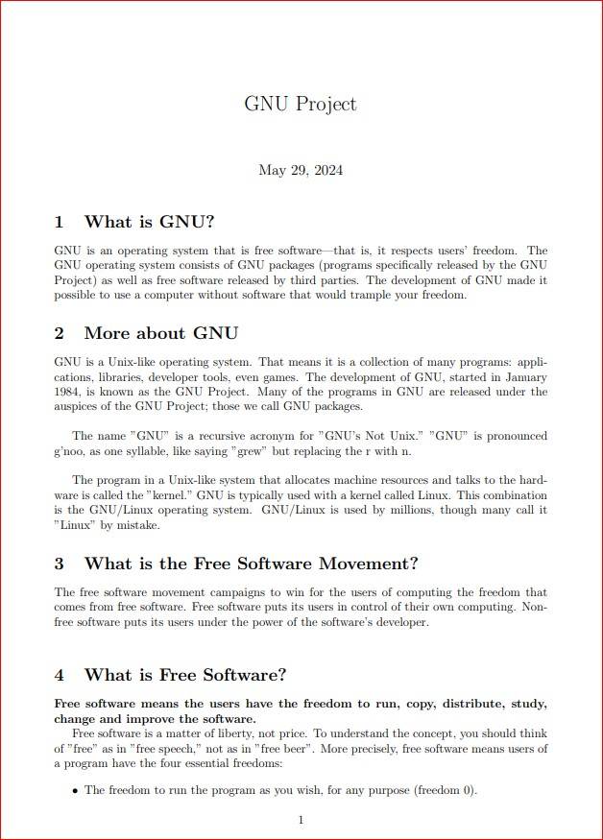**OUTPUT:**

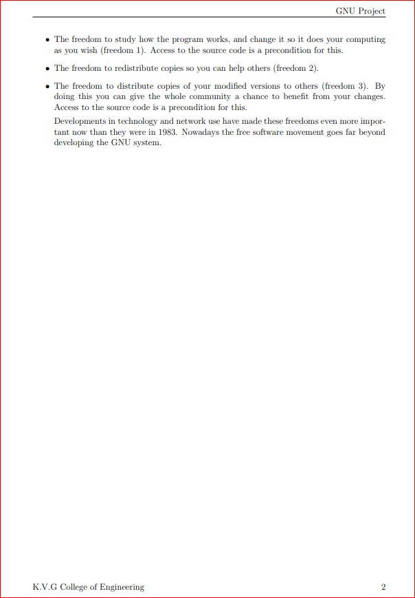

# EXPERIMENT 2:

## Develop a LaTeX script to create a document that displays the sample Abstract/Summary.

\documentclass[10pt,a4paper]{article}

\usepackage[utf8]{inputenc}

\usepackage{amsmath}

\usepackage{amsfonts}

\usepackage{amssymb}

\usepackage[left=3cm,right=3cm,top=2cm,bottom=2cm]{geometry}

%\usepackage{lipsum}

\begin{document}

\thispagestyle{plain}

\begin{center}

\Large

\textbf{Social Media}

\vspace{0.4cm}

\large

Raising Awareness on Social Media Fake News

\vspace{0.4cm}

\textbf{Sharath}

\vspace{0.9cm}

\textbf{Abstract}

\end{center}

%\lipsum[1]

The proliferation of fake news on social media platforms has become a pressing concern in contemporary society. This abstract delves into the multifaceted issue of fake news dissemination through social media and proposes strategies for enhancing awareness among users.

Firstly, it examines the mechanisms through which fake news spreads virally, exploiting the interconnected nature of social media networks. It elucidates how algorithms, echo chambers, and confirmation bias contribute to the rapid dissemination of misinformation.

Secondly, the abstract highlights the detrimental consequences of fake news, including its impact on public opinion, political discourse, and societal trust. By distorting reality and fostering polarization, fake news undermines the foundations of democracy and exacerbates social divisions.

Furthermore, it discusses existing efforts to combat fake news, such as fact-checking initiatives and platform interventions. While these measures are crucial, they often fall short in addressing the root causes of misinformation and in reaching diverse audiences.

To effectively raise awareness about social media fake news, the abstract suggests a holistic approach that combines education, media literacy, and technological innovations. It advocates for comprehensive media literacy programs in schools and communities, empowering individuals to critically evaluate online content and discern credible sources.

Moreover, the abstract underscores the importance of collaboration between tech companies, policymakers, and civil society in developing innovative solutions. This entails implementing transparency measures, enhancing algorithmic accountability, and promoting ethical design principles to mitigate the spread of fake news.

In conclusion, the abstract emphasizes the urgent need for collective action to combat the scourge of social media fake news. By fostering a culture of skepticism, critical thinking, and digital responsibility, society can fortify its defenses against misinformation and safeguard the integrity of public discourse in the digital age.

\end{document}

**OUTPUT:**

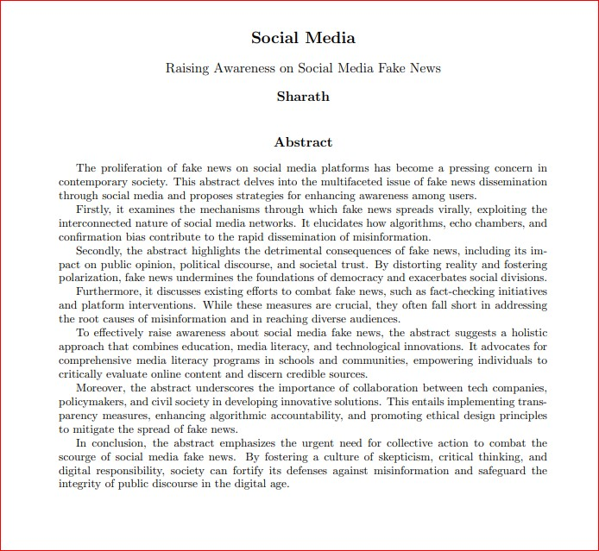

# EXPERIMENT 3:

## Develop a LaTeX script to create a simple title page of the VTU project Report [Use suitable Logos and text formatting]

\documentclass{report}

\usepackage{graphicx}

\usepackage{setspace}

\usepackage{geometry}

\newcommand{\titlepageVTU}{%

\begin{titlepage}

\begin{center}

\textbf{\LARGE KVG College of Engineering, Sullia}

\vspace{0.5cm}

\includegraphics[width=0.3\linewidth]{D:/latex all complete pr/vtu-logo.png}

\vspace{1cm}

\textbf{\LARGE Visvesvaraya Technological University}

\vspace{0.5cm}

{\Large Department of Computer Science and Engineering (AI \& ML)}

\vspace{2cm}

{\huge\textbf{YOGA}}

\vspace{2cm}

\textbf{\Large by}

\vspace{0.5cm}

{\Large Sharath}

\vfill

\textbf{\Large Prof. Suresh}

\vspace{0.5cm}

{\Large Your Co-guide's Name (if any)}

\vfill

{\large 4th Semester, 2024}

\end{center}

\end{titlepage}

}

\begin{document}

\titlepageVTU

\end{document}

**OUTPUT:**



# EXPERIMENT 4:

## Develop a LaTeX script to create the Certificate Page of the Report [Use suitable commands to leave the blank spaces for user entry]

\documentclass{report}

\usepackage{graphicx}

\begin{document}

\begin{center}

{\bfseries KVG COLLEGE OF ENGINEERING, SULLIA (D.K)}\\

{\small Affiliated To Visvesaraya Technological University, Belagavi}\\

{\bfseries DEPARTMENT OF COMPUTER SCIENCE AND ENGINEERING}

\begin{figure}[h]

\centering

\includegraphics[height=2cm]{D:/latex all complete pr/Kvg.jpg}

\end{figure}

{\LARGE\bfseries CERTIFICATE}

\end{center}

Certified that the project entitled \textbf{Hand Gesture Recognition} has been carried out by:

\begin{center}

\begin{tabular}{ll}

4KV23CI401 & Sharath \\

4KV22CI001 & Abhinav.P S \\

4KV22CI023 & Keerthan \\

4KV22CI006 & Ankith

\end{tabular}

\end{center}

in partial fulfillment of the requirements for the award of the degree of \textbf{Bachelor Of Engineering} in \textbf{Computer Science with Artificial Intelligence \& Engineering} of the \textbf{Visvesvaraya Technological University, Belagavi} during the academic year 2023-24. It is certified that all corrections/suggestions indicated for the internal assessment have been incorporated into the report. The project report has been approved as it satisfies the academic requirements in respect of project work prescribed for the Bachelor of Engineering Degree.

\begin{center}

\begin{tabular}{lll}

\textbf{Prof. KISHORE KUMAR K} & \textbf{Dr. SMITHA M L} & \textbf{Prof. VENKATESH U C} \\

Assistant Professor & Professor & Assistant Professor \\

Project Guide & Project Co-ordinator & Project Co-ordinator \\

\end{tabular}

\end{center}

\begin{center}

\begin{tabular}{lll}

\textbf{Dr. UJWAL.U.J} & & \textbf{Dr. SURESHA V} \\

Head of the Department & & Principal \\

\end{tabular}

\end{center}

\begin{center}

\begin{tabular}{llll}

Name of the Examiners: & 1. \_\_\_\_\_\_\_\_\_\_\_\_\_\_ & Signature with Date: & \_\_\_\_\_\_\_\_\_\_\_\_\_\_ \\

& \\

& 2. \_\_\_\_\_\_\_\_\_\_\_\_\_\_ & & \_\_\_\_\_\_\_\_\_\_\_\_\_\_

\end{tabular}

\end{center}

\end{document}

**OUTPUT:**



# EXPERIMENT 5:

## Develop a LaTeX script to create a document that contains the following table with proper labels.

\documentclass{article}

\usepackage{multirow}

\begin{document}

\begin{table}[h!]

\centering

\caption{Table with student data}

\label{tab:table}

\begin{tabular}{|c|c|c|c|c|c|}

\hline

\multirow{2}{*}{S. No} & \multirow{2}{*}{USN} &

\multirow{2}{*}{Student Name} & \multicolumn{3}{c|}{Marks} \\

\cline{4-6}

& & & Subject 1 & Subject 2 & Subject 3 \\

\hline

1 & kv107 & Sharath & 89 & 87 & 90 \\

\hline

2 & kv108 & Abhinav & 79 & 89 & 95 \\

\hline

3 & kv109 & Krishna & 77 & 90 & 97 \\

\hline

\end{tabular}

\end{table}

\end{document}

**OUTPUT:**

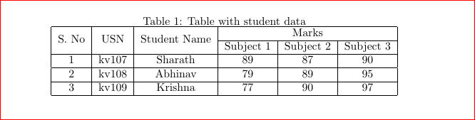

# EXPERIMENT 6:

## Develop a LaTeX script to include the side-by-side graphics/pictures/figures in the document by using the subgraph concept.

\documentclass[10pt,a4paper]{article}

\usepackage[utf8]{inputenc}

\usepackage{amsmath}

\usepackage{amsfonts}

\usepackage{amssymb}

\usepackage{caption}

\usepackage{subcaption}

\usepackage{graphicx}

\usepackage[left=2cm,right=2cm,top=2cm,bottom=2cm]{geometry}

\begin{document}

\section*{Subfigure Demo}

\begin{figure}[h]

\centering

\begin{subfigure}[b]{0.3\textwidth}

\centering

\includegraphics[width=\textwidth]{D:/latex all complete pr/1.jpg}

\caption{$y=x$}

\label{fig:y equals x}

\end{subfigure}

\hfill

\begin{subfigure}[b]{0.3\textwidth}

\centering

\includegraphics[width=\textwidth]{D:/latex all complete pr/2.png}

\caption{$y=3\sin x$}

\label{fig:three sin x}

\end{subfigure}

\hfill

\begin{subfigure}[b]{0.3\textwidth}

\centering

\includegraphics[width=\textwidth]{D:/latex all complete pr/3.png}

\caption{$y=5/x$}

\label{fig:five over x}

\end{subfigure}

\caption{Three simple graphs arranged side-by-side}

\label{fig:three graphs}

\end{figure}

\end{document}

**OUTPUT:**

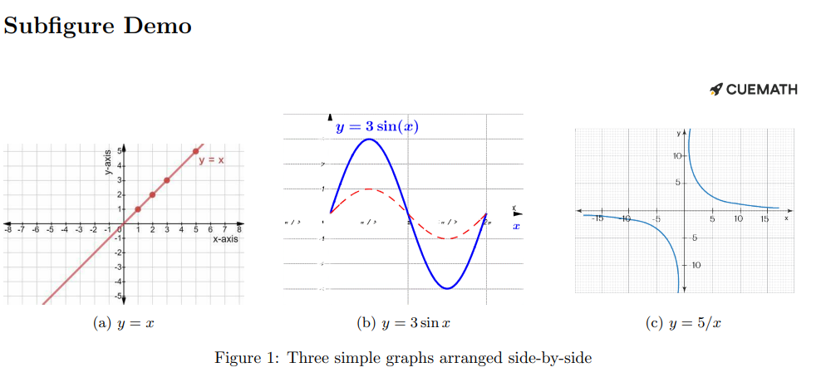

# EXPERIMENT 7:

## Develop a LaTeX script to create a document that consists of the following two mathematical equations.

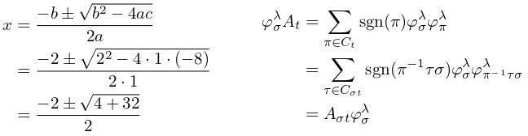

\documentclass{article}

\usepackage{amsmath}

\begin{document}

\title{Following Two Mathematical Equations}

\date{}

\maketitle

\[

\begin{aligned}

x &= \frac{-b \pm \sqrt{b^2 - 4ac}}{2a} \\

&= \frac{-2 \pm \sqrt{2^2 - 4 \cdot 1 \cdot (-8)}}{2 \cdot 1} \\

&= \frac{-2 \pm \sqrt{4 + 32}}{2}

\end{aligned}

\quad \quad \quad

\begin{aligned}

\varphi_{\sigma}^{\lambda} A_{t} &= \sum_{\pi \in C_{t}} \operatorname{sgn}(\pi) \varphi_{\sigma}^{\lambda} \varphi_{\pi}^{\lambda} \notag \\

&= \sum_{\tau \in C_{\sigma t}} \operatorname{sgn}(\pi^{-1} \tau \sigma) \varphi_{\sigma}^{\lambda} \varphi_{\pi^{-1} \tau \sigma}^{\lambda} \notag \\

&= A_{\sigma t} \varphi_{\sigma}^{\lambda}

\end{aligned}

\]

\end{document}

**OUTPUT:**

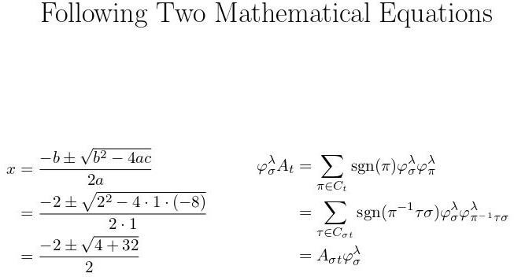

# EXPERIMENT 8:

## Develop a LaTeX script to demonstrate the presentation of Numbered theorems, definitions, corollaries, and lemmas in the document.

\documentclass{article}

\usepackage{amsthm}

\newtheorem{theorem}{Theorem}

\newtheorem{definition}{Definition}

\newtheorem{corollary}{Corollary}

\newtheorem{lemma}{Lemma}

\begin{document}

\title{Numbered Theorems, Definitions, Corollaries, and Lemmas in the Document}

\date{}

\maketitle

\begin{theorem}

(Pythagorean Theorem) In a right-angled triangle, the square of the length of the hypotenuse is equal to the sum of the squares of the lengths of the other two sides.

\begin{equation}

a^2 + b^2 = c^2

\end{equation}

\end{theorem}

\begin{definition}

(Prime Number) A prime number is a natural number greater than 1 that is not divisible by any number other than 1 and itself.

\begin{itemize}

\item Example: 2, 3, 5, and 7 are prime numbers.

\end{itemize}

\end{definition}

\begin{corollary}

(Euclid's Corollary) There are infinitely many prime numbers.

\begin{itemize}

\item Proof: Assume there are finitely many primes. Let them be $p_1, p_2, \ldots, p_n$. Consider the number $N = p_1 \cdot p_2 \cdots p_n + 1$. This number is not divisible by any of the primes $p_1$ through $p_n$. Therefore, there must be a prime factor not in the list, contradicting the assumption that there are only finitely many primes.

\end{itemize}

\end{corollary}

\begin{lemma}

(Basic Arithmetic Identity) For any real numbers $a$ and $b$, we have:

\begin{equation}

(a + b)^2 = a^2 + 2ab + b^2.

\end{equation}

\end{lemma}

\end{document}

**OUTPUT:**

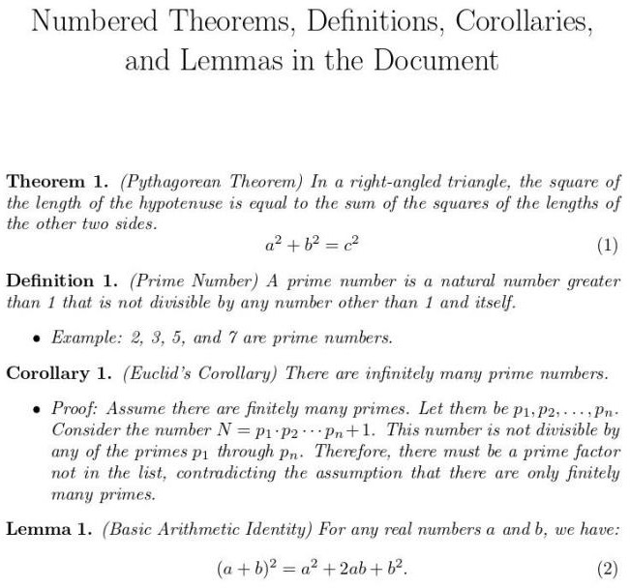

# EXPERIMENT 9:

## Develop a LaTeX script to create a document that consists of two paragraphs with a minimum of 10 citations in it and display the reference in the section.

\documentclass{article}

\usepackage[numbers]{natbib}

\begin{document}

\title{Document that Consists of Two Paragraphs with a minimum of 10 Citations in it and Displaying the References in the Section}

\date{}

\maketitle

\paragraph{Paragraph 1}

The theory of relativity has been explored extensively in various scientific papers \citep{author1, author2, author3}. Einstein's contributions to physics are profound and have paved the way for many modern discoveries \citep{author4, author5}. Researchers continue to

investigate the complexities of spacetime and the universe \citep{author6, author7}. These advancements have led to new methods of measurement and analysis in cosmology \citep{author8}.

\paragraph{Paragraph 2}

Recent studies have focused on the impact of climate change on various ecosystems \citep{author9, author10}. Scientists are examining how rising temperatures and changing weather patterns affect biodiversity and human health \citep{author11, author12}. Furthermore, interdisciplinary research has brought about innovative solutions for sustainable development \citep{author13}. Collaboration among experts from different fields is essential to address the challenges of global warming \citep{author14}.

\newpage

\begin{thebibliography}{99}

\bibitem{author1} Author One. \textit{Title of Article One}. Journal Name, vol. 10, no. 1, pp. 1--10, 2022.

\bibitem{author2} Author Two. \textit{Title of Book Two}. Publisher Name, 2021.

\bibitem{author3} Author Three. \textit{Title of Conference Paper Three}. In: Proceedings of Conference, pp. 100--110, 2020.

\bibitem{author4} Author Four. \textit{Title of Article Four}. Journal Name, vol. 9, no. 2, pp. 15--25, 2019.

\bibitem{author5} Author Five. \textit{Title of Book Five}. Publisher Name, 2018.

\end{thebibliography}

\end{document

**OUTPUT:**

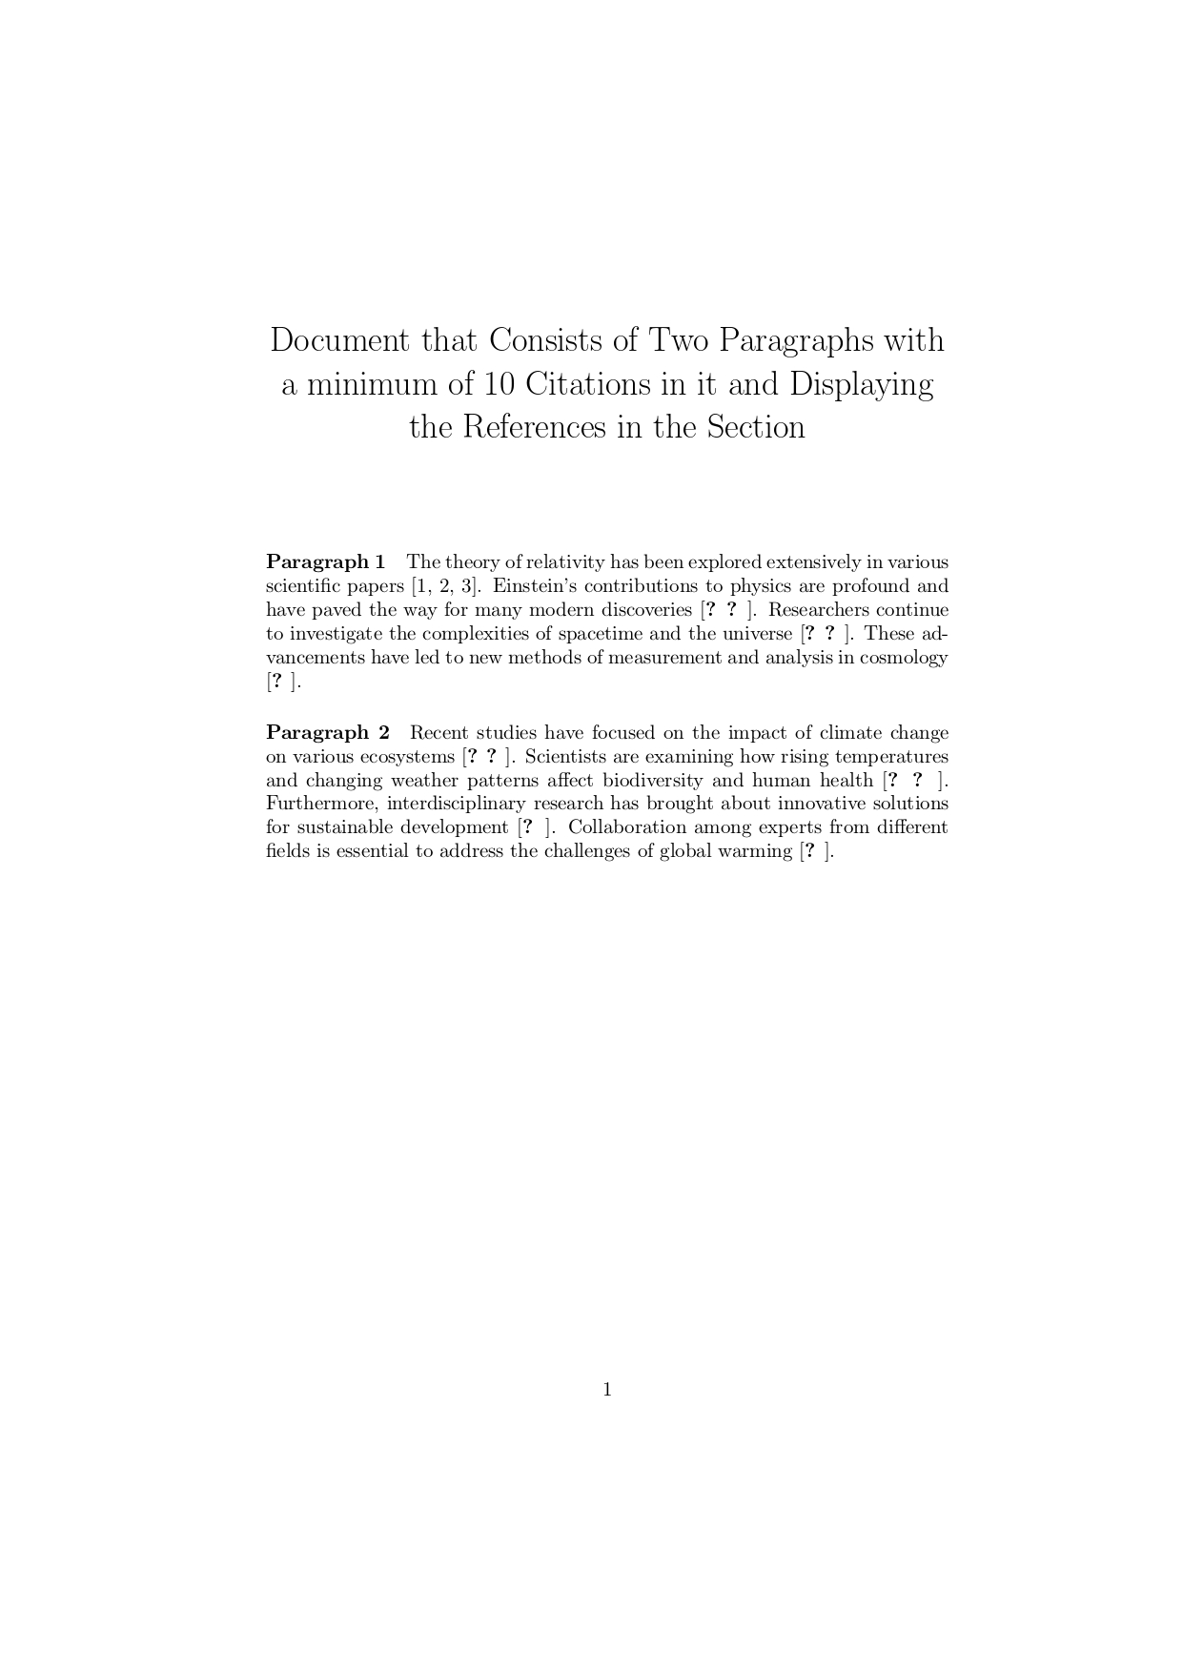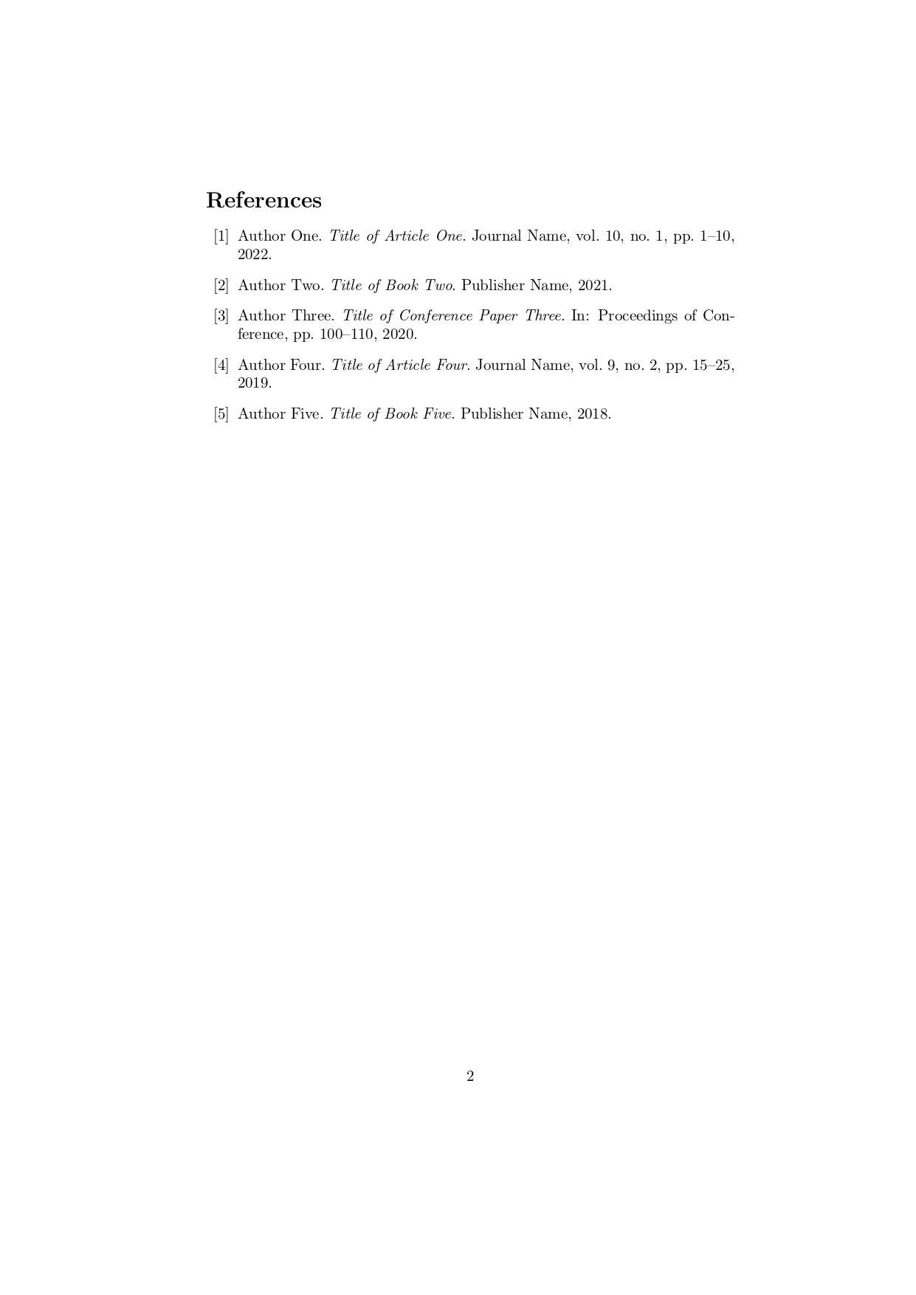

# EXPERIMENT 10:

## Develop a LaTeX script to design a simple tree diagram or hierarchical structure in the document with appropriate labels using the Tikz library.

\ \documentclass{article}

\usepackage{tikz}

\usetikzlibrary{trees}

\begin{document}

\title{Simple Tree Diagram or Hierarchical Structure in the Document with appropriate Labels using the TikZ Library}

\date{}

\maketitle

\begin{center}

\begin{tikzpicture}[

level 1/.style={sibling distance=7cm},

level 2/.style={sibling distance=4cm},

level distance=2cm,

every node/.style={font=\large} % Increase font size here (e.g. \large, \Large)

]

\node {Root}

child { node {Child 1}

child { node {Grandchild 1.1} }

child { node {Grandchild 1.2} }

}

child { node {Child 2}

child { node {Grandchild 2.1} }

child { node {Grandchild 2.2} }

};

\end{tikzpicture}

\end{center}

\end{document}

**OUTPUT:**

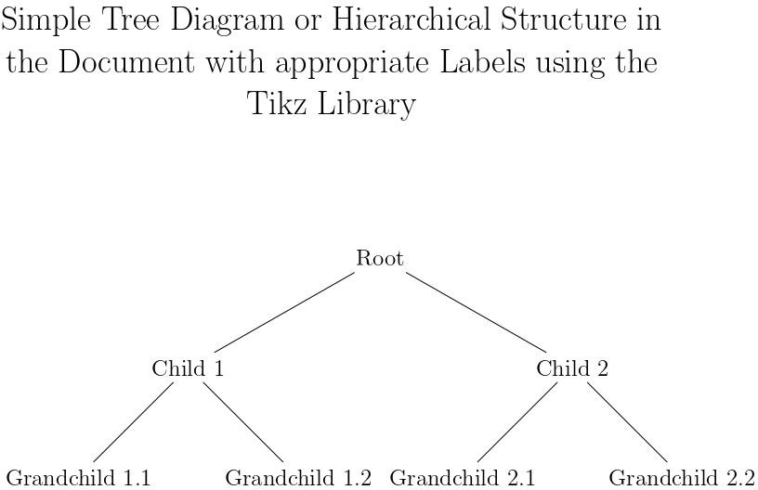

# EXPERIMENT 11:

## Develop a LaTeX script to present an algorithm in the document using Algorithm/algorithmic/algorithm2e library.

\documentclass{article}

\usepackage[ruled, linesnumbered]{algorithm2e}

\begin{document}

\begin{algorithm}[H]

\SetAlgoLined

\SetKwFunction{Dijkstra}{Dijkstra}

\SetKwProg{Fn}{Function}{:}{}

\Fn{\Dijkstra{$G, s$}}{

$d[s] \gets 0$\;

\ForEach{$v \in V$}{

$d[v] \gets \infty$\;

$prev[v] \gets$ undefined\;

}

$Q \gets V$\;

\While{$Q$ is not empty}{

$u \gets$ vertex in $Q$ with minimum $d[u]$\; Remove $u$ from $Q$\;

\ForEach{$v \in$ neighbors of $u$}{

$alt \gets d[u] + \mathrm{weight}(u, v)$\;

\If{$alt < d[v]$}{

$d[v] \gets alt$\;

$prev[v] \gets u$\;

}

}

}

\KwRet{$d[], prev[]$}\;

}

\caption{Dijkstra's Algorithm}

\label{algo:dijkstra}

\end{algorithm}

\end{document}

**OUTPUT:**

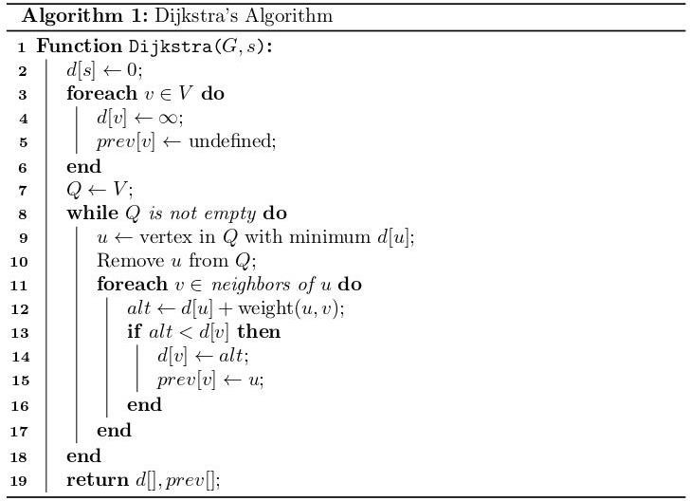

# EXPERIMENT 12:

## Develop a LaTeX script to create a simple report and article by using suitable commands and formats of user choice.

\documentclass[6pt,a4paper]{report}

\usepackage[utf8]{inputenc}

\usepackage{amsmath}

\usepackage{amsfonts}

\usepackage{amssymb}

\usepackage{graphicx}

\usepackage[left=3cm,right=3cm,top=2cm,bottom=2cm]{geometry}

\author{Lekhaka}

\title{Sharath}

\begin{document}

\maketitle

\chapter{Free Software}

\section*{What is Free Software?}

"\textbf{Free software}" means software that respects users' freedom and community. Roughly, it means that \textbf{the users have the freedom to run, copy, distribute, study, change and improve the software}. Thus, "free software" is a matter of liberty, not price. To understand the concept, you should think of "\textit{free}" as in "\textit{free speech}," not as in "\textit{free beer}." We sometimes call it "\textbf{libre software}," borrowing the French or Spanish word for "free" as in freedom, to show we do not mean the software is gratis.

You may have paid money to get copies of a free program, or you may have obtained copies at no charge. But regardless of how you got your copies, you always have the freedom to copy and change the software, even to sell copies.

We campaign for these freedoms because everyone deserves them. With these freedoms, the users (both individually and collectively) control the program and what it does for them. When users don't control the program, we call it a "\textit{nonfree}" or "\textit{proprietary}" program. The nonfree program controls the users, and the developer controls the program; this makes the program an instrument of unjust power.

"\emph{Open source}" is something different: it has a very different philosophy based on different values. Its practical definition is different too, but nearly all open source programs are in fact free.

\section*{The Free Software Definition}

The free software definition presents the criteria for whether a particular software program qualifies as free software. \\

\textbf{The four essential freedoms} \\

A program is free software if the program's users have the four essential freedoms: \\

\begin{itemize}

\item The freedom to run the program as you wish, for any purpose (freedom 0).

\item The freedom to study how the program works, and change it so it does your computing as you wish (freedom 1). Access to the source code is a precondition for this.

\item The freedom to redistribute copies so you can help others (freedom 2).

\item The freedom to distribute copies of your modified versions to others (freedom 3).

\end{itemize}

By doing this you can give the whole community a chance to benefit from your changes. Access to the source code is a precondition for this. \\

A program is free software if it gives users adequately all of these freedoms. Otherwise, it is nonfree. While we can distinguish various nonfree distribution schemes in terms of how far they fall short of being free, we consider them all equally unethical.

\chapter{Listing Environment}

\begin{small}

\section*{Unordered lists}

\subsection*{Groceries List}

\begin{itemize}

\item Eggs

\item Milk

\item Biscuits

\item Rice

\end{itemize}

\subsection*{Football Teams}

\begin{itemize}

\item English Premier League

\begin{itemize}

\item Manchester United

\item Liverpool

\end{itemize}

\item La Liga

\begin{itemize}

\item Barcelona

\item Real Madrid

\end{itemize}

\item Bundesliga

\begin{itemize}

\item Bayern Munich

\item Borussia Dortmund

\end{itemize}

\end{itemize}

\section*{Ordered lists}

\subsection*{ICC WTC Rankings}

\begin{enumerate}

\item India

\item Australia

\item New Zealand

\end{enumerate}

\subsection*{Countries ranked by Market Cap}

\begin{enumerate}

\item Asia

\begin{enumerate}

\item China

\item Japan

\item India

\end{enumerate}

\item Europe

\begin{enumerate}

\item United Kingdom

\item France

\item Germany

\end{enumerate}

\end{enumerate}

\end{small}

\end{document}

**OUTPUT:**

